Carpenter Co.
Acoustic Nonwovens

Leave the Noise Behind

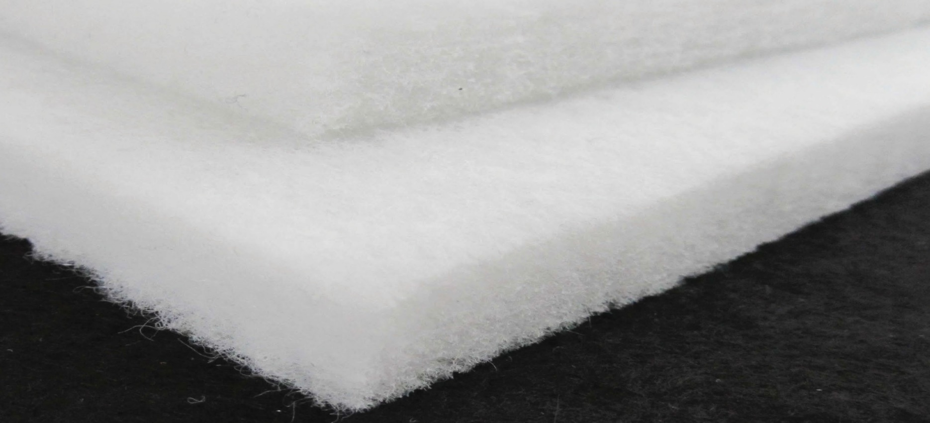
Shortest Lead Times in the Industry

Multiple Manufacturing Facilities in the United States

Capable of Producing Identical Material at Multiple Plants

Custom Design & Product Development Available for Specific Customer Applications
Carpenter Co. introduces its line of polyester nonwovens designed for acoustic applications. Carpenter’s unmatched quality, efficiency, and logistics make us the clear choice for all of your acoustical and thermo-formable fiber needs. From coast to coast, we are there when and where you need us. We are not just a supplier; we are your partner in development.

Carpenter Co.
Acoustic Nonwovens

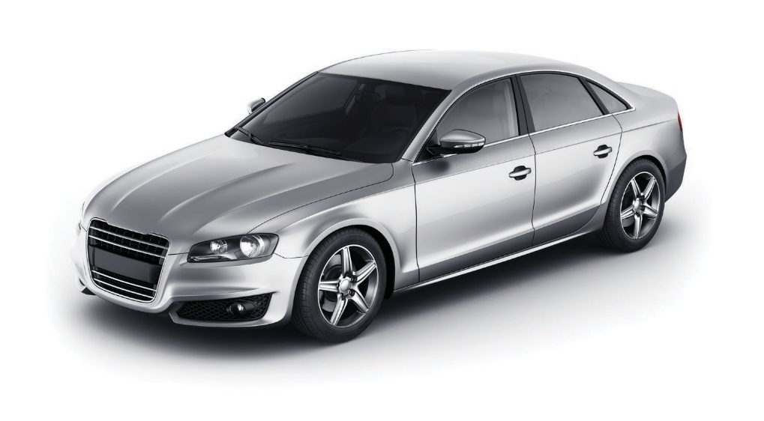
Headliner
Trunk

Body Side Panels

Console

Doors

Wheel Wells
Product Types
High loft Needle Punch
High loft products provide low frequency absorption Densified nonwovens provide more durable materials
at low basis weights with excellent high frequency suitable for demanding applications while providing
absorption. sound absorption

Custom Specifications
Dedicated product development team at the Reinhart Technical Center allows custom tailored performance to meet your precise requirements.

High Loft Range |  |  | Needle Punch Range
Basis Weight | Thickness |  | Basis Weight | Loft
125 - 1200 gsm | 10 - 100 mm |  | 135 - 1200 gsm | 1.5 - 19 mm
(0.4 - 4.0 oz/ft2) | (0.4 - 4.0 inch) |  | (0.44- 4.0 oz/ft2) | (0.05 - 4.0) inch

Used by major automotive manufacturers

Corporate Headquarters
Reinhart Technical Center
Manufacturing & Customer Service Centers

5016 Monument Ave. Richmond, VA 23230 (804) 359-0800 acoustics@carpenter.com
2600 Jefferson Davis Highway
Richmond, VA 23234
(804) 233-0606
acoustics@carpenter.com
Riverside, CA Elkhart, IN Russellville, KY
Tupelo, MS Conover, NC Fogelsville, PA
Temple, TX Richmond, VA

The Carpenter logo and “We bring comfort to your life” are registered trademarks of Carpenter Co.
The Ford, GM, Toyota and Chrysler logos are registered trademarks of their respective companies.

